**VCS Task**

Establish a new directory, populate it with script files, initiate an empty repository on GitHub, convert the local directory into a Git repository, and link it to GitHub for pushing the code into the repository. Perform merge, rebase, and stash commands in the following GitHub repo.

* **Establish a new directory, populate it with script files**

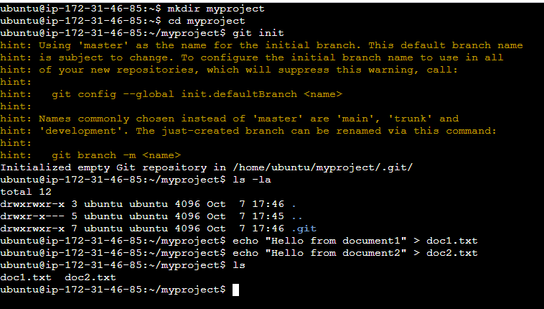

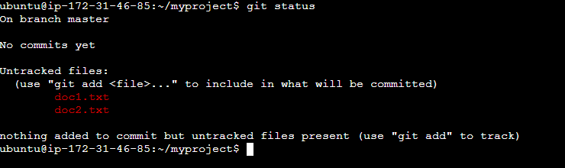

* **Create an empty repository in GitHub**

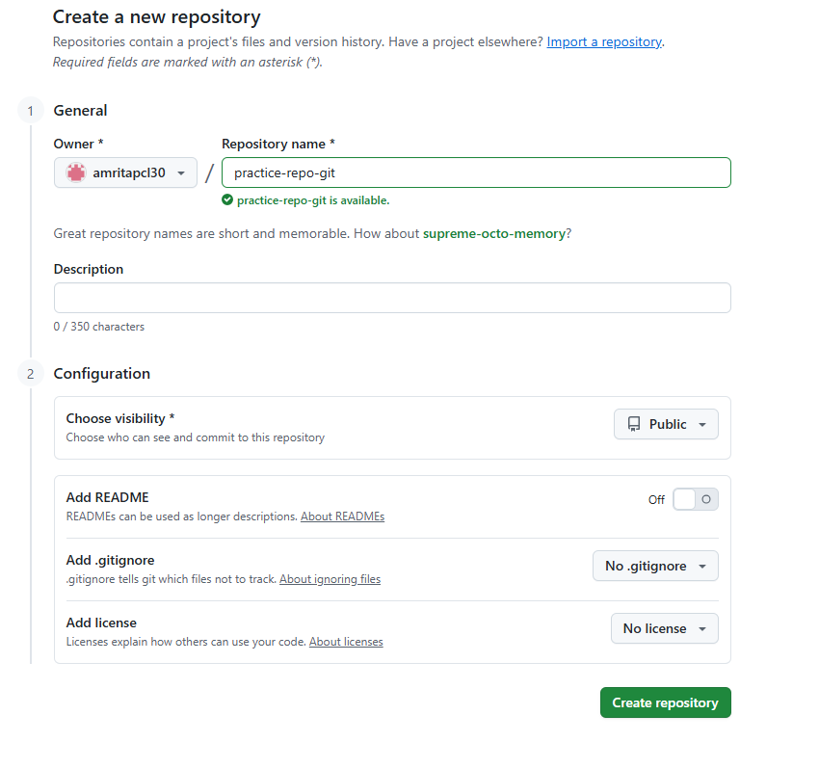

* **Add and commit files**

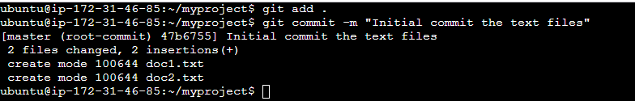

* **Connect local repo to GitHub**

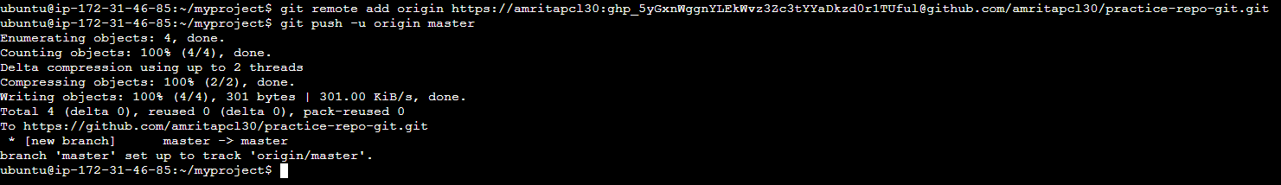

* **. Create a new branch and merge**

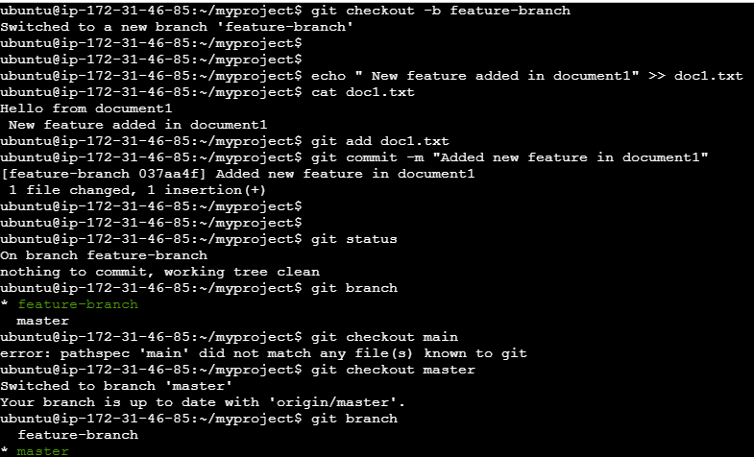

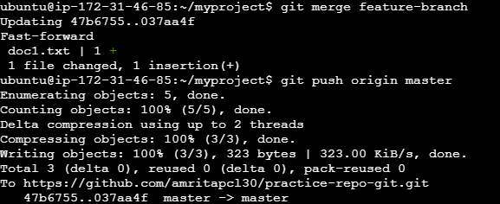

* **Practice Rebase**

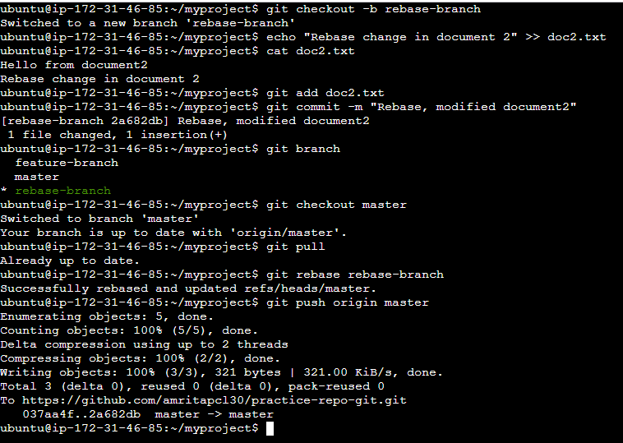

* **Practice Stash**

